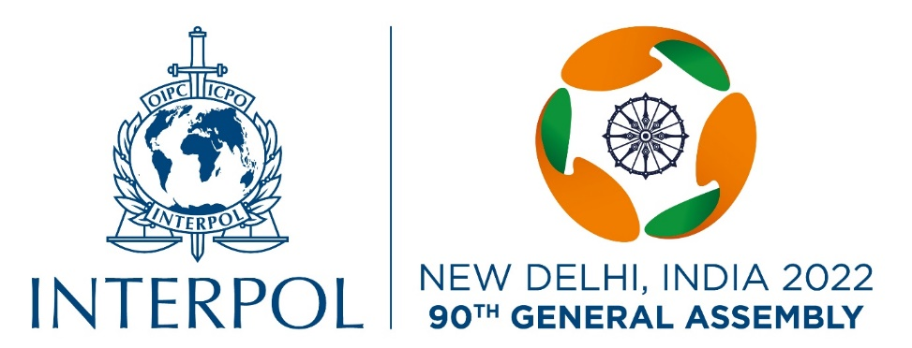

Press Accreditation Form
90th INTERPOL General Assembly - New Delhi, India, 18-21 October

Title | Mr./Ms./Mrs. (Please tick as applicable)
First name

Family name (s)

E-mail

Phone No. (landline) & Mobile No.

Nationality

Residential Address
Professional Journalist Card Number:
(attach copy)
Passport No. & Date of issue:
Valid up to:
(attach a copy)

Visa No. & Date of issue:
(must visit on Journalist Visa)
Valid up to:
(attach a copy)

Name of Media Organization

Headquarters street address with phone number

Office Address in India with phone number
(If, foreign media has office in India)
Organization Website

(Signature)

Please complete and e-mail the form, along with a good quality colour photograph in JPEG format (with full name as the photo title) and all required documents no later than Monday, 10 October, 2022 to: adg@cbi.gov.in, Tel: +91 1124361156.

